EXP NO: 6
Servlet-Based Login System Demonstrating Session Tracking with HttpSession

AIM:
Write a Servlet to demonstrate session tracking using HttpSession. Implement a simple login system where the user's session is tracked.
CODE:
Session.html
<!DOCTYPE html>
<html>
<head>
<meta charset="ISO-8859-1">
<title>HTTP Session</title>
</head>
<body>
<h1>Form Handle By HTTP Session</h1>
<form action="./HttpSessionHandle" method="POST" style="margin-left: 50px">
<label>Username: </label><input type="text" name="username"/><br><br>
<label>Password: </label><input type="password" name="password"/><br><br>
<input type="submit" value="Login" style="margin-left: 130px"/>
</form>
</body>
</html>

HttpSessionHandle.Java
package com.karthick.servlet;

import java.io.IOException;
import java.io.PrintWriter;

import javax.servlet.ServletException;
import javax.servlet.annotation.WebServlet;
import javax.servlet.http.HttpServlet;
import javax.servlet.http.HttpServletRequest;
import javax.servlet.http.HttpServletResponse;
import javax.servlet.http.HttpSession;

/**
* Servlet implementation class HttpSessionHandle
*/
@WebServlet("/HttpSessionHandle")
public class HttpSessionHandle extends HttpServlet {
private static final long serialVersionUID = 1L;

/**
* @see HttpServlet#HttpServlet()
*/
public HttpSessionHandle() {
super();
// TODO Auto-generated constructor stub
}

/**
* @see HttpServlet#doGet(HttpServletRequest request, HttpServletResponse response)
*/

@SuppressWarnings("deprecation")
protected void doPost(HttpServletRequest request, HttpServletResponse response) throws ServletException, IOException {
String username = "WTMA";
String password = "WTMA";

PrintWriter p = response.getWriter();
String user = request.getParameter("username");
String pass = request.getParameter("password");

if(user.equals(username) && pass.equals(password))
{
HttpSession session = request.getSession(true);
session.putValue("username", user);

response.sendRedirect(request.getContextPath() + "/HttpSessionHandleDisplay");
}

else
{
p.println("fail");
}
}
}

HttpSessionHandleDisplay.Java
package com.karthick.servlet;

import java.io.IOException;
import java.io.PrintWriter;

import javax.servlet.ServletException;
import javax.servlet.annotation.WebServlet;
import javax.servlet.http.HttpServlet;
import javax.servlet.http.HttpServletRequest;
import javax.servlet.http.HttpServletResponse;
import javax.servlet.http.HttpSession;

/**
* Servlet implementation class HttpSessionHandleDisplay
*/
@WebServlet("/HttpSessionHandleDisplay")
public class HttpSessionHandleDisplay extends HttpServlet {
private static final long serialVersionUID = 1L;

/**
* @see HttpServlet#HttpServlet()
*/
public HttpSessionHandleDisplay() {
super();
// TODO Auto-generated constructor stub
}

/**
* @see HttpServlet#doGet(HttpServletRequest request, HttpServletResponse response)
*/
protected void doGet(HttpServletRequest request, HttpServletResponse response) throws ServletException, IOException {
PrintWriter p = response.getWriter();
HttpSession session = request.getSession(true);

@SuppressWarnings("deprecation")
String user_name = (String)session.getValue("username");
p.println("Usernmae is " + user_name);
}

/**
* @see HttpServlet#doPost(HttpServletRequest request, HttpServletResponse response)
*/
protected void doPost(HttpServletRequest request, HttpServletResponse response) throws ServletException, IOException {
// TODO Auto-generated method stub
doGet(request, response);
}

}

OUTPUT:
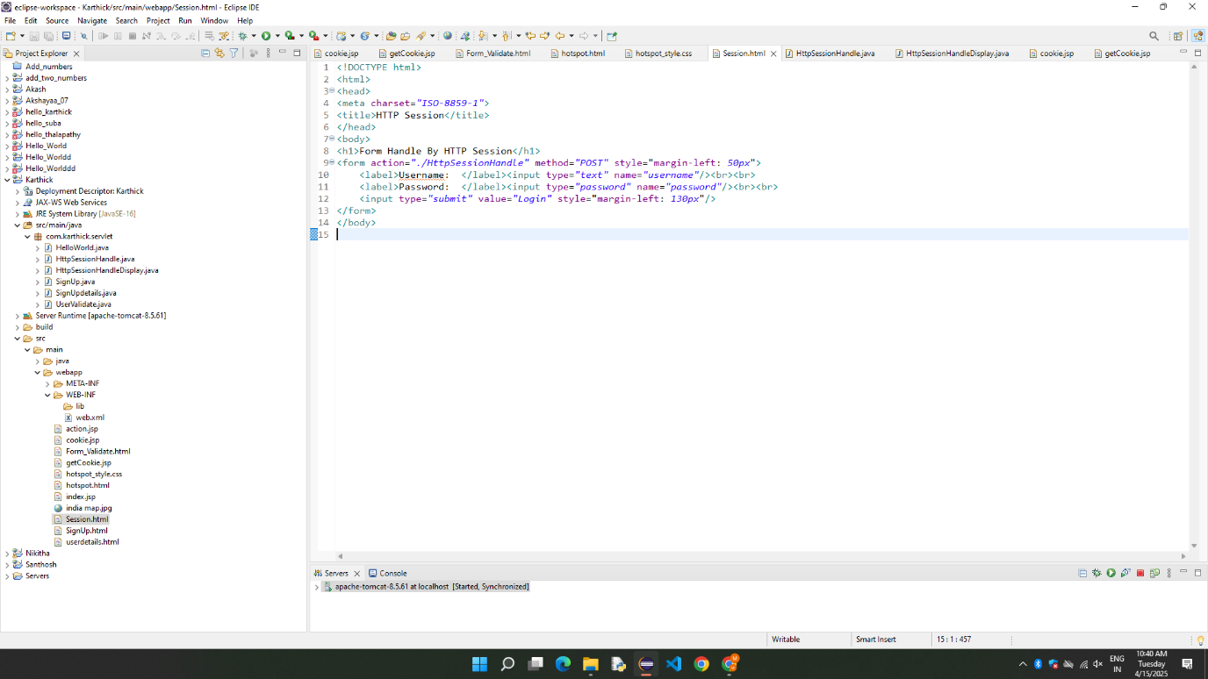

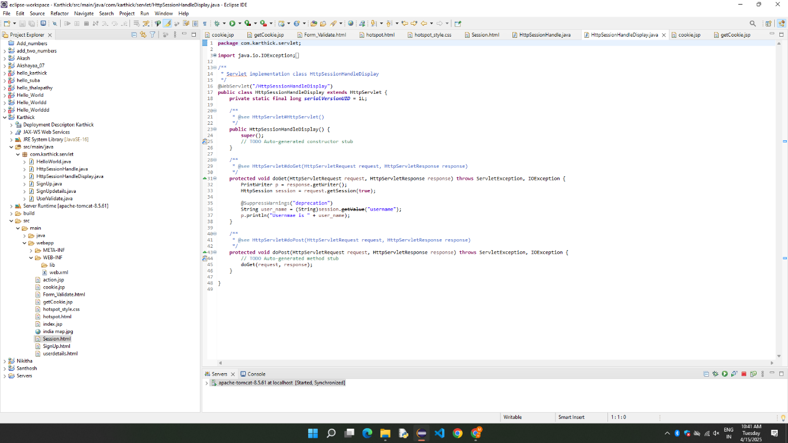

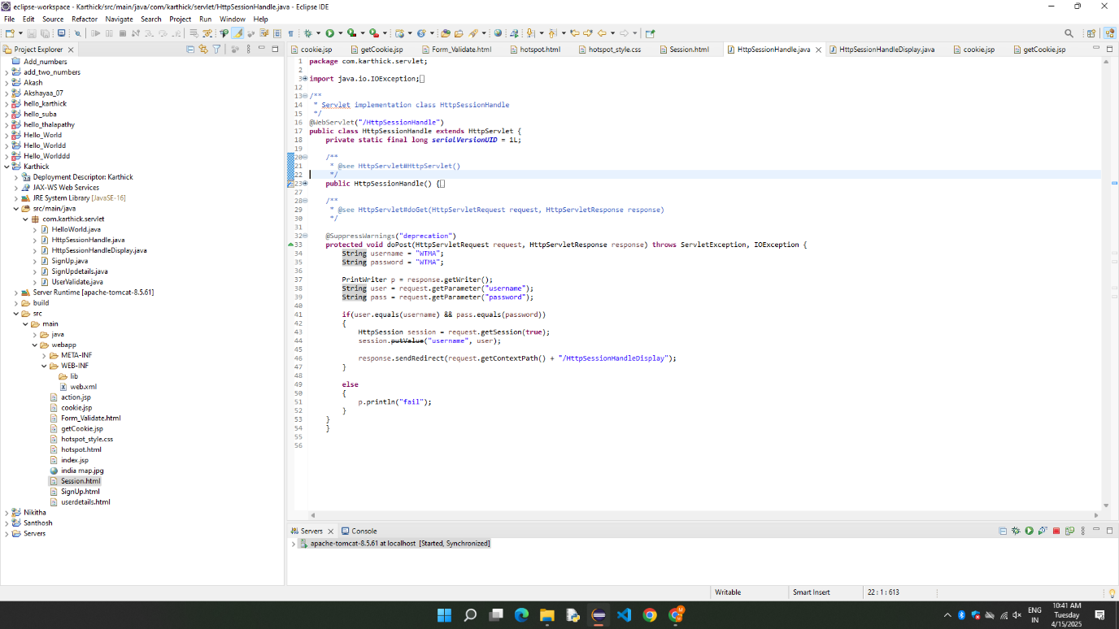

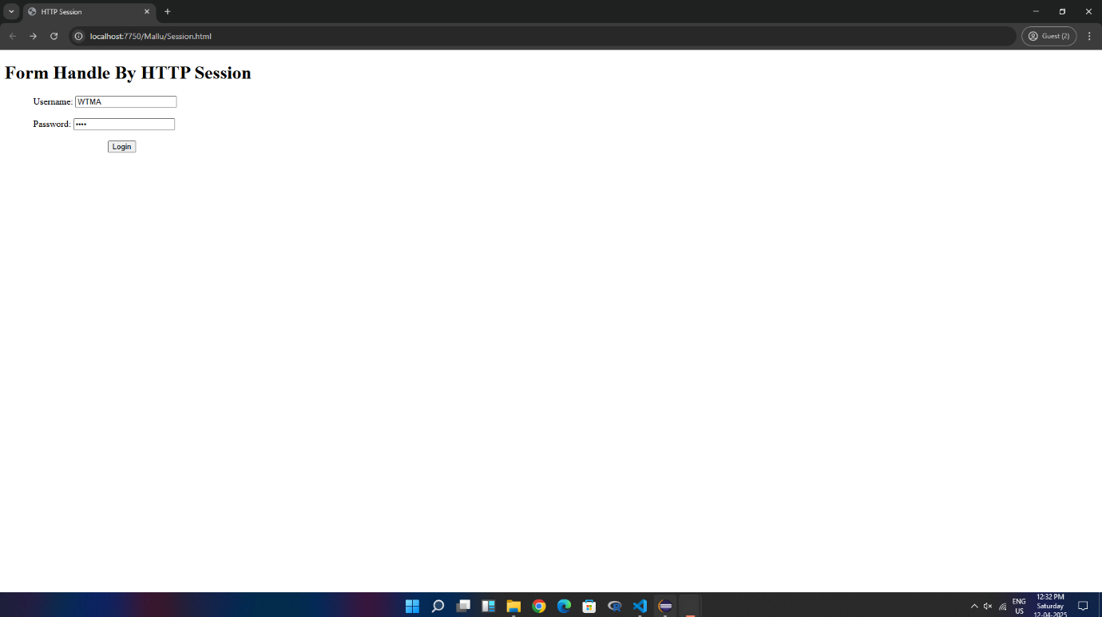

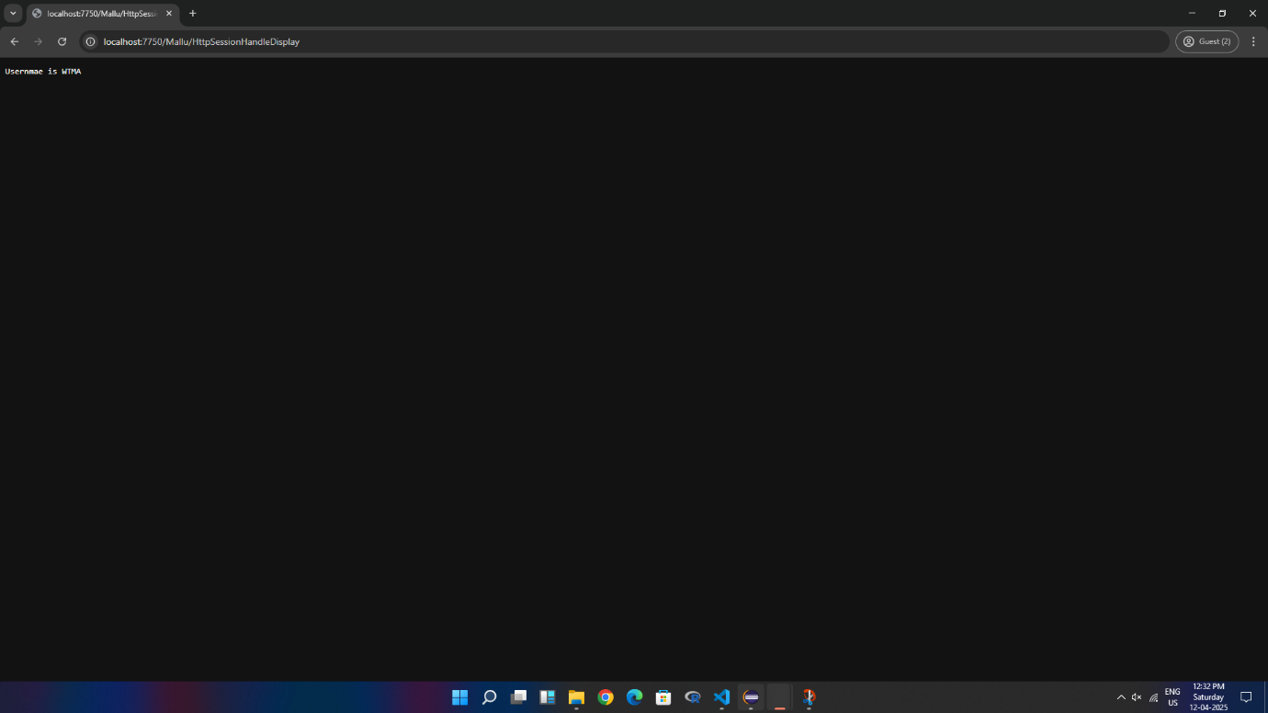

RESULT:
Thus, the Session Tracking is demonstrated using HTTP session.

